db.books.update({isbn: "999-888"}, {$set: {author: "Simon Collins"}})

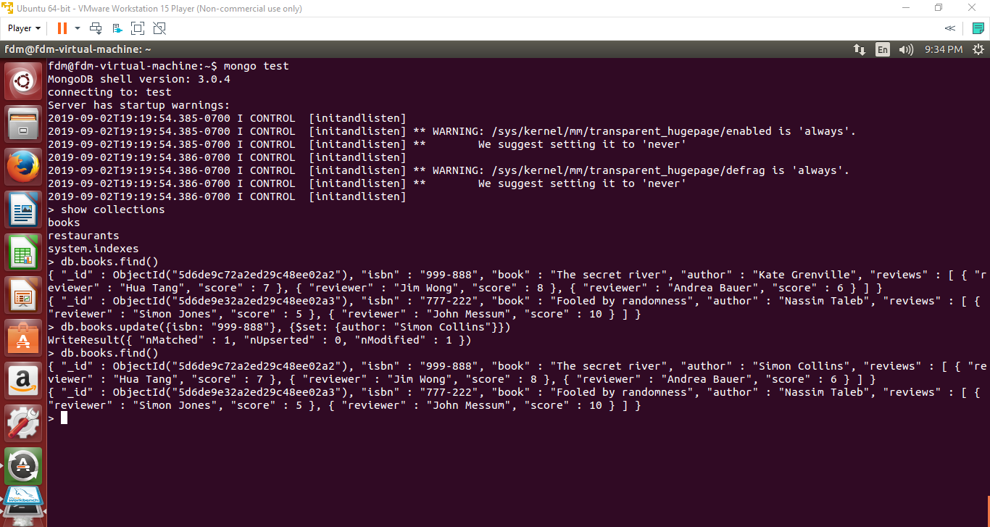

The response you get when the update is successful is WriteResult({ “nMatched”: 1, “nUpserted”: 0, “nModified: 1 })

Upsert is an option for the update method. When it is set to true, if the update query cannot find a match, it will insert a document. To avoid inserting the same index more than once, upsert should only be used when the query field is uniquely indexed.